Understanding Reports
Objective
After completing this lesson, you will be able to use various types of reports to document and analyze your processes.
Introduction to Reports
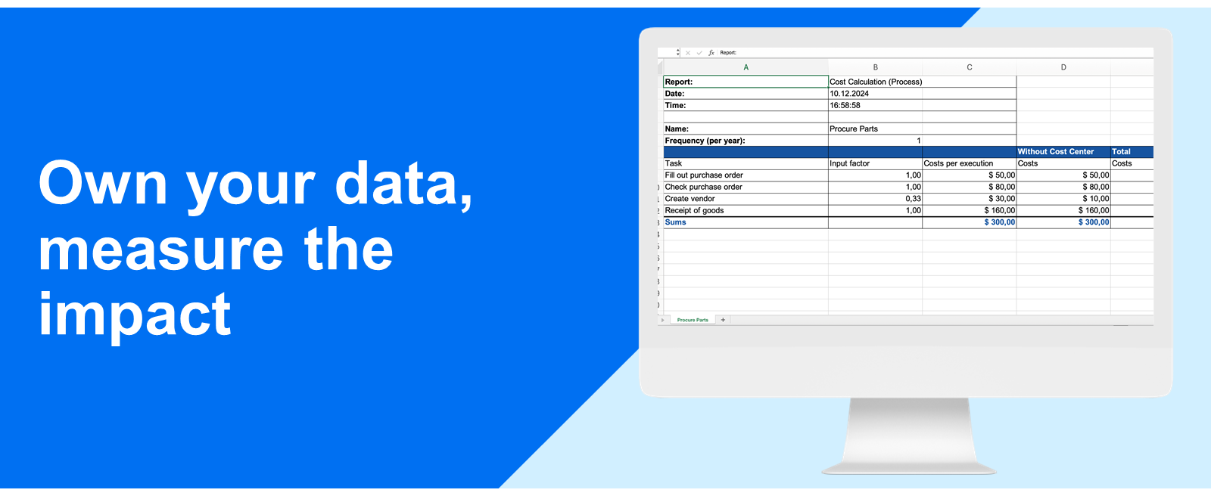
The processes you create contain both visible and hidden information, the latter being in the attributes. There are many scenarios in which you might want to collect this data. For example, as proof of controls for auditors or as a source of information for stakeholders. The reporting feature allows you to easily aggregate information across many processes as well as to focus on specific aspects of individual models. In the familiar form of spreadsheets or PDF files, the generated reports can then be used to guide decision-making. The broad range of reports can help you answer questions such as:
- Can we reduce costs? If yes, where?
- Where do we have many handoffs?
- Who is responsible for which tasks?
- In which processes and activities are we using which IT-Systems?
- Have internally defined modeling standards been considered?
- Do our models have redundant information that could be merged?
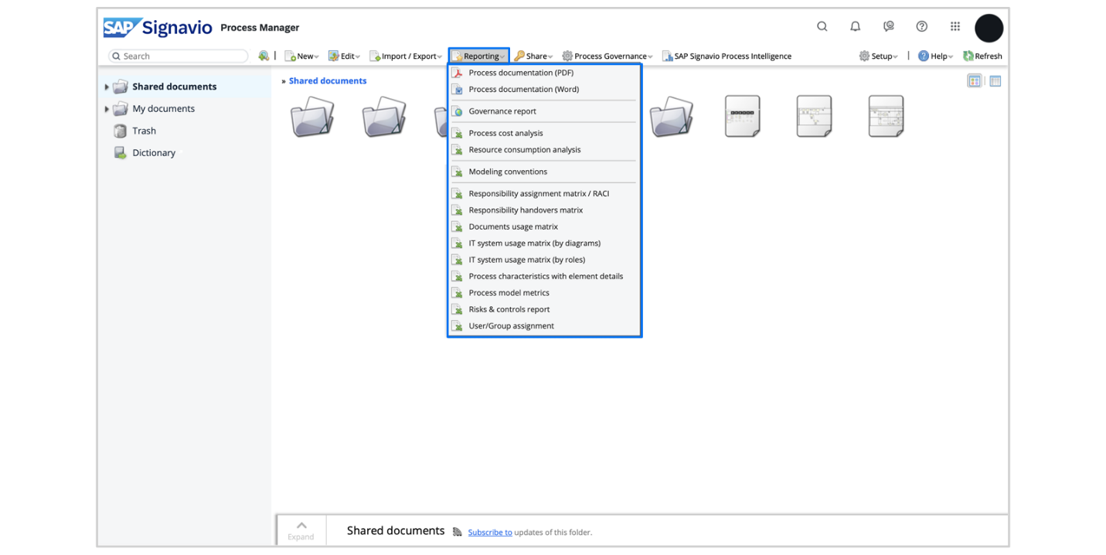
In the following sections, we’ll focus on the different report types available. You’ll learn what information is necessary to run them, as well as what scenarios they might be helpful in.
Hint
The reports can also be generated in the SAP Signavio Process Collaboration Hub.
Analysis Reports
As you create process models, you can provide information such as execution time, execution cost, and cost center in the attributes of the individual process steps. This data is then used during the process cost and the resource consumption analyses. Watch the video below to learn more about them.
Process Cost Analysis
This report determines the execution costs for every task, while also displaying the relevant cost centers. The analysis uses the yearly frequency as set in the attributes of the model’s start event. If the diagram contains any gateways, the probability of the different paths will be reflected in the calculation as the task’s input factor. The following list provides you with some of the benefits this analysis can bring:
- Forecast and plan your budget better by making data-driven decisions about where to invest and where to cut back.
- Identify activities within your processes that are driving up costs. This information can be crucial for targeting areas that need improvement or optimization.
- Find inefficiencies in your processes. By identifying and addressing these, you can streamline your operations, reduce costs, and improve overall efficiency.
- Identify activities not adding any value and waste, contributing to further optimization.
Resource Consumption Analysis
This report focuses on the workload of process participants. It calculates the time consumed for each task and organizes the results by department. Additional information on allowances and work times is used for the calculation. Continue reading to learn a few scenarios in which you could use the resource consumption analysis:
- Allocate budgets effectively by understanding which departments or roles consume the most resources.
- Identify which resources are involved in the most time-consuming activities, allowing process managers to target these areas for optimization.
- Detect and analyze bottlenecks caused by resource constraints, enabling managers to redistribute workloads or allocate additional resources.
Matrices
In every process model, the responsibilities for tasks are clearly defined by the lanes and pools in which they are placed. Additionally, task-level attributes and diagram elements can provide further information on the roles involved. The same applies to data about IT systems and document usage. There are four different report types that aggregate this information, showing you who and what is involved in your processes.
The following section will explain these matrices and provide you with possible use cases. We’ll begin with the responsibility reports. Watch the video below to get an overview of them.
Responsibility Assignment Matrix
The RACI report maps tasks and deliverables against roles in a process, clearly showing who’s responsible for which process steps. In addition to the responsibility for a task, it’s possible to define who is accountable, consulted, or informed by assigning these roles in the attributes panel. Here are some beneficial use cases:
- Prevent and resolve conflicts by clearly defining who is responsible, accountable, consulted, and informed for specific tasks.
- Use the RACI Matrix as part of training materials to educate team members on their roles and responsibilities.
- Eliminate any confusion and ensure smooth transitions or handoffs in case of a turnover.
- Standardize roles and responsibilities across various processes to ensure consistency.
- Facilitate internal audits by providing clear documentation of role assignments and accountability.
- Understand the impact of process changes on roles and responsibilities.
Responsibility Handovers Matrix
Based on the connecting objects in your process models - the sequence and the message flows - this report captures the handovers between process participants. Exactly knowing where the process gets handed over can help you:
- Decide between which teams or stakeholders should communication be prioritized.
- Manage stakeholder expectations by showing when and how they will be involved in the process.
Let's now turn our attention to the usage reports. Watch the next video to learn more about them.
IT System Usage Matrix
This report shows you which IT systems data is read from and written to during your processes. To deepen your analysis, you can also choose to group by roles rather than diagrams. Some advantages of these reports include:
- Check which systems are heavily used and which stay underutilized to guide your resource allocation decisions.
- Identify potential points of failure or security risks by finding single systems on which critical process heavily rely on.
- Look for areas where additional user training may be needed.
- Know who to inform when an IT system is interrupted or in maintenance.
Document Usage Matrix
With this report, you can see which documents are assigned to which tasks in your processes, either as inputs or outputs. Such an overview can help you to:
- Understand the connections between different processes or process steps by seeing where the same documents are used.
- Reduce confusion related to document access and ownership.
- Check if any outdated or incorrect documents are being used.
Process Management & Maintenance
Whereas the previous analyses were primarily based on the data in the model attributes, the following report types broaden their focus and consider element usage in general. They can provide you with insightful statistics about individual as well as multiple diagrams. If you’re responsible for process management and governance in your organization at large, these can prove very useful.
Modeling Conventions
With this report you can check if the selected diagrams are compliant with the BPMN conventions and your workspace's custom modeling rules.​ Let’s imagine your organization requires that all processes have all mandatory custom attributes set as well as that their lanes are always labeled and linked to your dictionary. It would be pretty cumbersome to manually check whether each process follows these rules, right? Furthermore, this report can help you assess whether the process modelers adhere to the conventions. Numerous violations may be an indicator for the need of additional training.
Before you create the report, you can also make use of the filter options to further specify your results. For example, you only want to evaluate published ISO relevant processes that don’t have any process description. In the image below, you see that we checked the box for published processes and chose "equals true" for our custom attribute ISO 9000ff relevant. We also selected Description and defined the filters to only show processes where this field is empty.
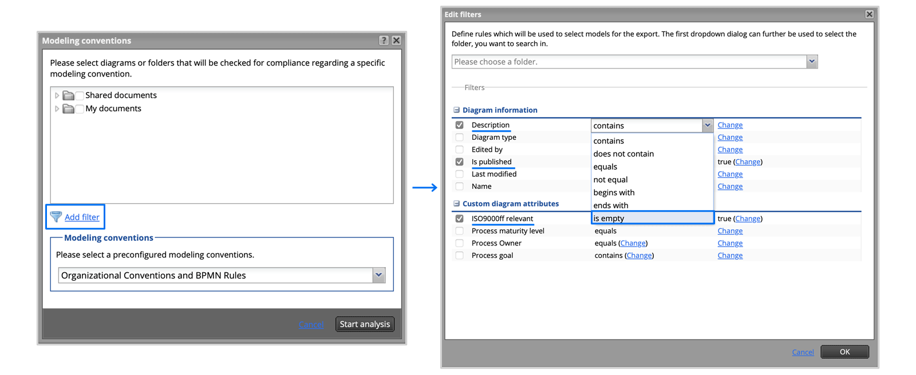
In the next image, you can see a report generated with the filters applied. The errors being marked in red allows you to immediately focus on the areas where your attention is most needed. You can expand the spreadsheet’s columns by clicking on the plus signs to see more details about the individual errors, warnings, and hints.
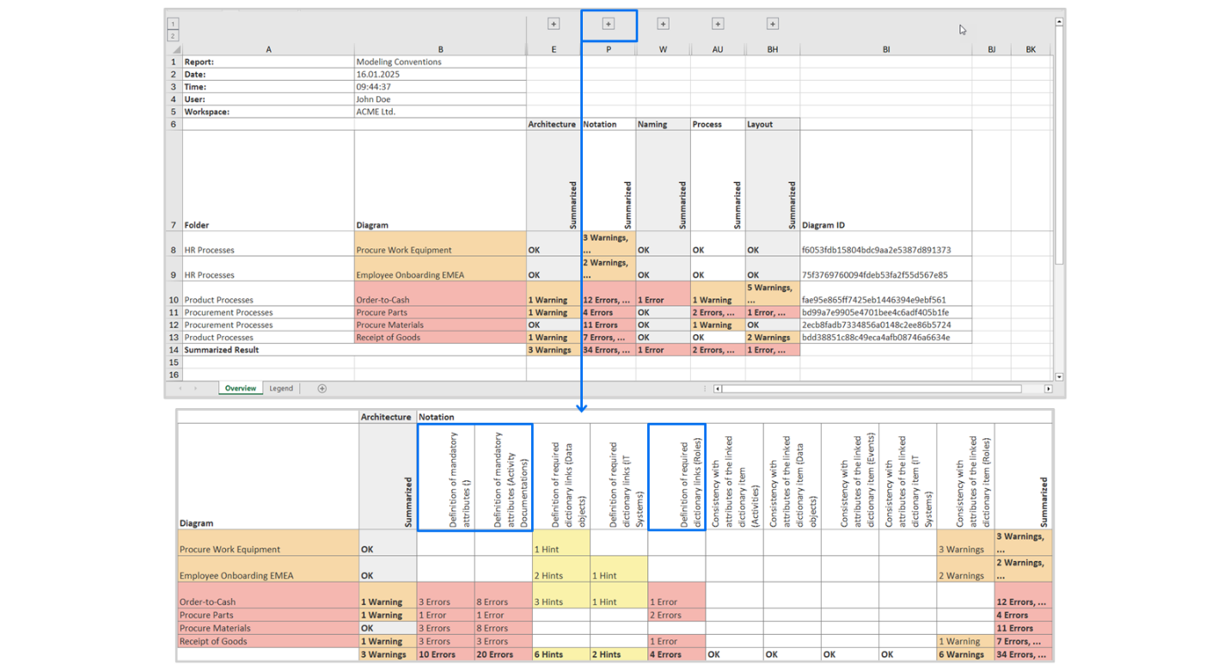
Hint
In the additional sheet you can find a legend which lists all the conventions that have been checked.
Process Model Metrics
With the process model metrics report you can generate a statistics report for your diagrams with detailed information about the elements used, such as their number and type. You’ll also see how many files and dictionary entries were linked. Moreover, the report provides you with links to the diagram in the Process Manager as well as in the Collaboration Hub.
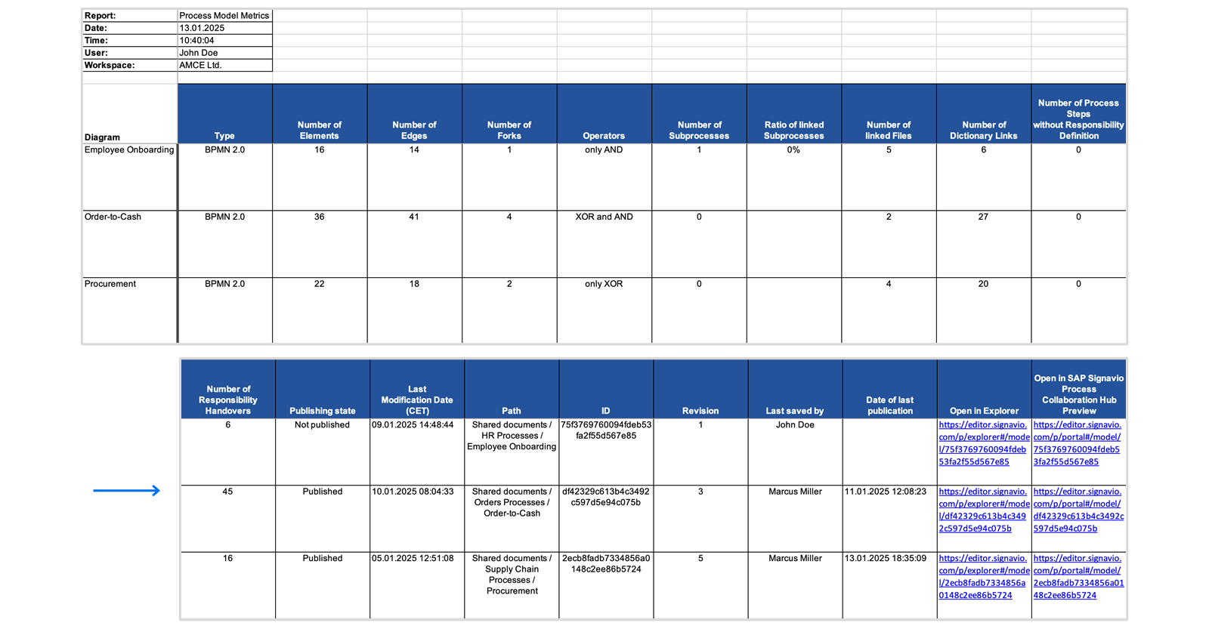
Here are some scenarios in which this report type can prove useful:
- Highlight processes with a high number of activities, gateways, or complex structures that may be difficult to manage or understand.
- Retrieve the process ID as a unique identifier.
- Use the links to embed the process diagrams internally, for example, intranet or in a presentation for stakeholders.
- Find unpublished diagrams and review their relevance using other data from the report, for example, the latest author or last modification date.
Process Characteristics
This report provides you with a list of the BPMN elements used in your models. In addition to specifying their type, it also shows the attributes which have been filled out. Attributes without any values across the selected processes will not be displayed in the report.
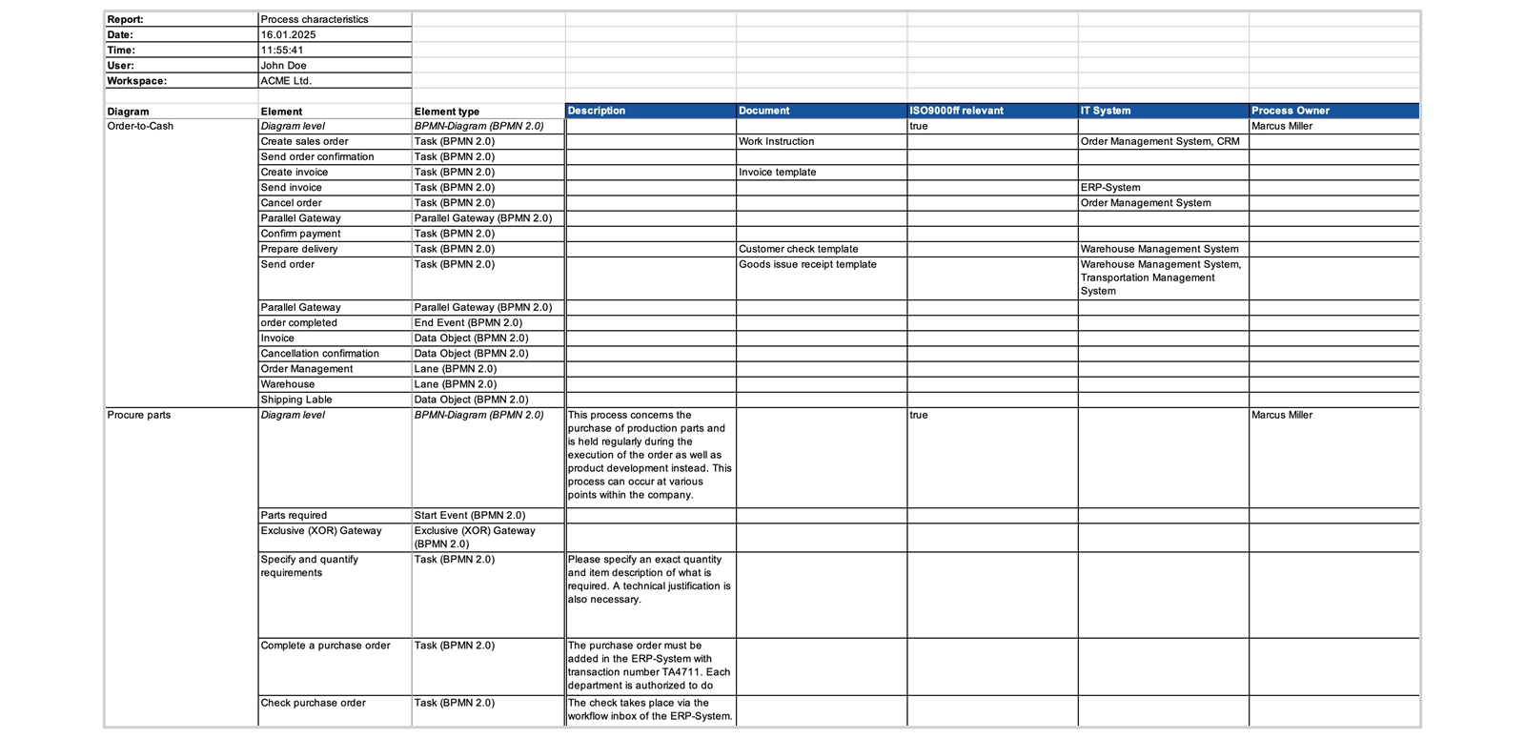
When would you need such a report? Here some use cases:
- See immediately if there are any redundancies in your attributes and merge duplicated information.
- Compare element and attribute usage across processes to see if they need to be aligned.
- Access an overview of process attributes to easily find relevant information such as process owners or certification requirements all in one place.
Risks and Controls
This report summarizes the information about risks and controls in the selected process diagrams, as defined in the Dictionary. ​You'll be able to see their descriptions, as well as other important data, such as relevant documents or control frequency.
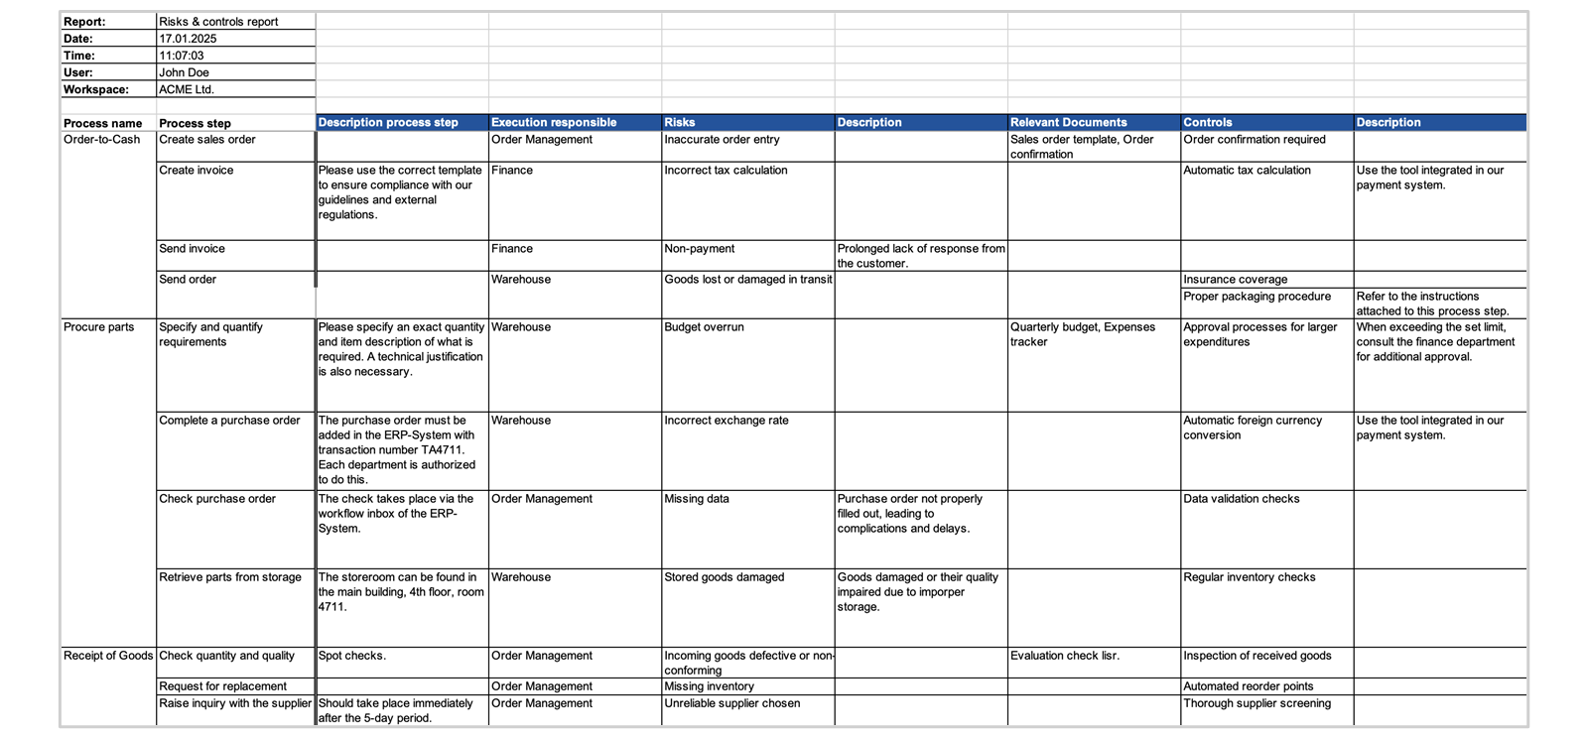
If your company is maintaining risks and related controls in the process attributes, this report can help you to:
- Identify and evaluate potential risks and their impacts on the organization.
- Demonstrate compliance with industry standards, laws, and regulations, by preparing the report for regulatory bodies, auditors, or other stakeholders.
- Find control gaps and areas for improvement.
- Discover and manage IT-related risks, such as data breaches, system failures, and cyber-attacks by monitoring the effectiveness of IT controls.
Process Documentation
So far, we have learned about standardized report types. These are very advantageous, but you might sometimes want to create a report that’s more tailored to your needs. That’s where the process documentation comes in. It is a comprehensive document that can contain diagram graphics as well as relevant diagram attributes, such as element descriptions or dictionary entries. You can create it either as PDF or – for easy customization and formatting – a Microsoft Word file. Furthermore, it’s possible to design custom templates that can be used when generating process documentations. Here are some scenarios in which you would find process documentation useful:
- Create an overview of all BPMN 2.0 process diagram tasks used.
- Generate a matrix with all dictionary entries linked.
- Access a detailed summary of the elements used.
- Provide a process overview for QM certification purposes (for example, ISO 9000ff).
- Design a process handout (such as work instructions) to involve employees without access to the Collaboration Hub.
- Generate a document with specific information, such as attributes, that is relevant to external participants.
You can keep your templates simple or make them more advanced, for example, by creating multilingual documentations that suit your organization's requirements.
Watch the video below to learn how to configure the content and the visual properties of your process documentations. You’ll quickly see that creating and editing templates follows the same logic of the Editor. You can drag and drop objects on the canvas and make further adjustments in the attributes panel. For more information consult the Help Portal.
Note
To create templates, you need to be granted the respective access rights by the administrator.
If you would like to see how a template-based process documentation can look like, check out the following examples:
- Example Documentation QM ISO 9000ff
- Example Process Handout
- Example Process Fact Sheet

